**REACT JS MINI PROJECT MUSIC STORE**

**Documentation**

**Technologies To Be Used:**

HTML, CSS, JavaScript, Bootstrap, React.JS, Node, JSON Server, Redux, Axios, **(Deployment if possible).**

**Project Overview:**

This project works in the manner of a fully functional e-commerce app where we have certain features:

1. **Pages (With Routes):** Home page, About Page, Contact Page, Login Page, Products Page, Products By Category, CRUD Page, Shopping Cart Page, Final Order Page, Admin Page, Customer Page.
2. **Components:** Admin Component, Home Component, Browse Component, Store Component, Details Component, Cart Component, Login Component, Checkout Component, Logout Component.

**Modules Used:**

1. **Admin:** CRUD Process on Products, Admin Module is secured and we need to perform admin activities. Admin route should be secured**.**
2. **Customer:** View Products, View Products By Category, Add or Remove a product, see a product’s details, checkout.
3. **Shopping Cart Module:** Display all the products in cart, show grand total of all the products, customer can remove a product and when all the additions are done on the cart, customer can proceed for the checkout.

**THIS IS THE LANDING PAGE:- localhost:3000**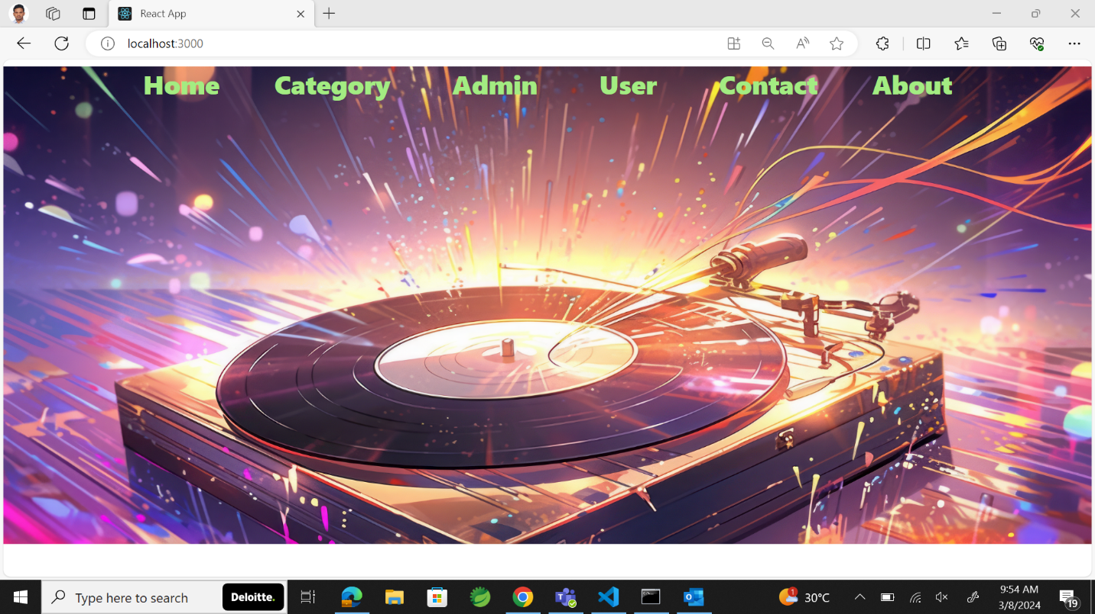

**Here the Navigation bar contains**

**1)Home**

**2) Category**

**3)Admin**

**4)User**

**5)Contact**

**6)About**

**1)HOME**



**2)Category**

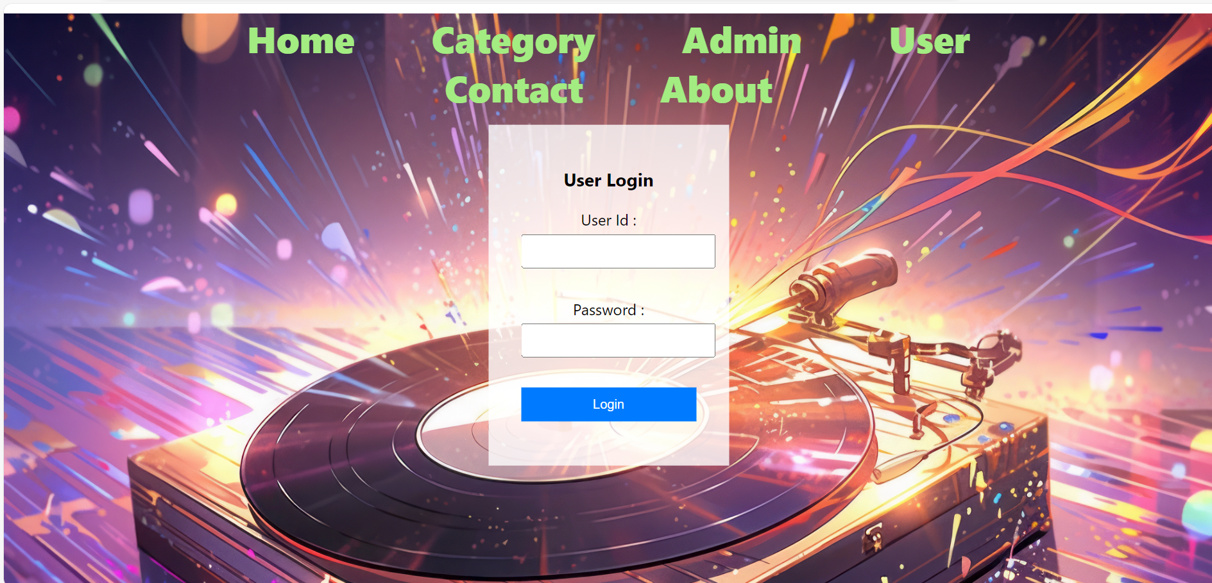

**To perform any operations the first thing the user/admin should do is login. Login is of two types:**

**3)Admin**

**4)User**

**Admin login:**

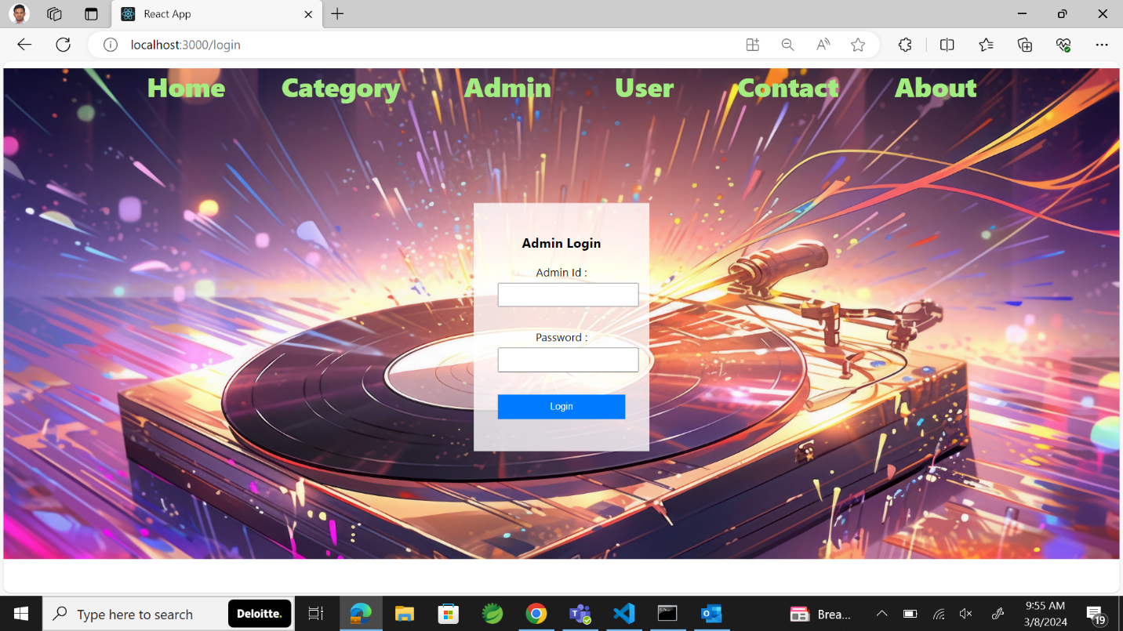

* Here the Admin Login values are static.
* The admin id = admin and Admin password = admin123.
* If either the id or password is wrong, it throws an error which is like invalid Admin Id or Password.
* 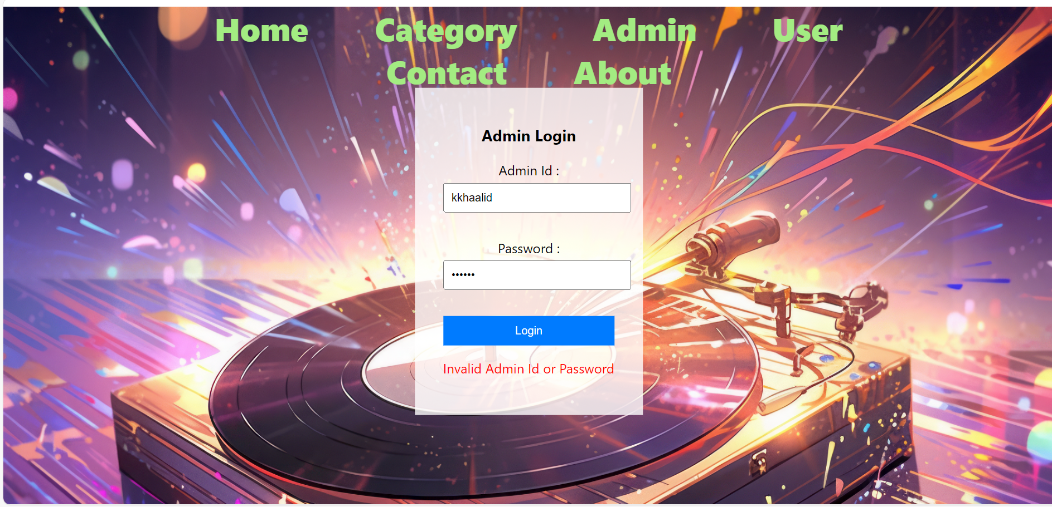

**User Login:**

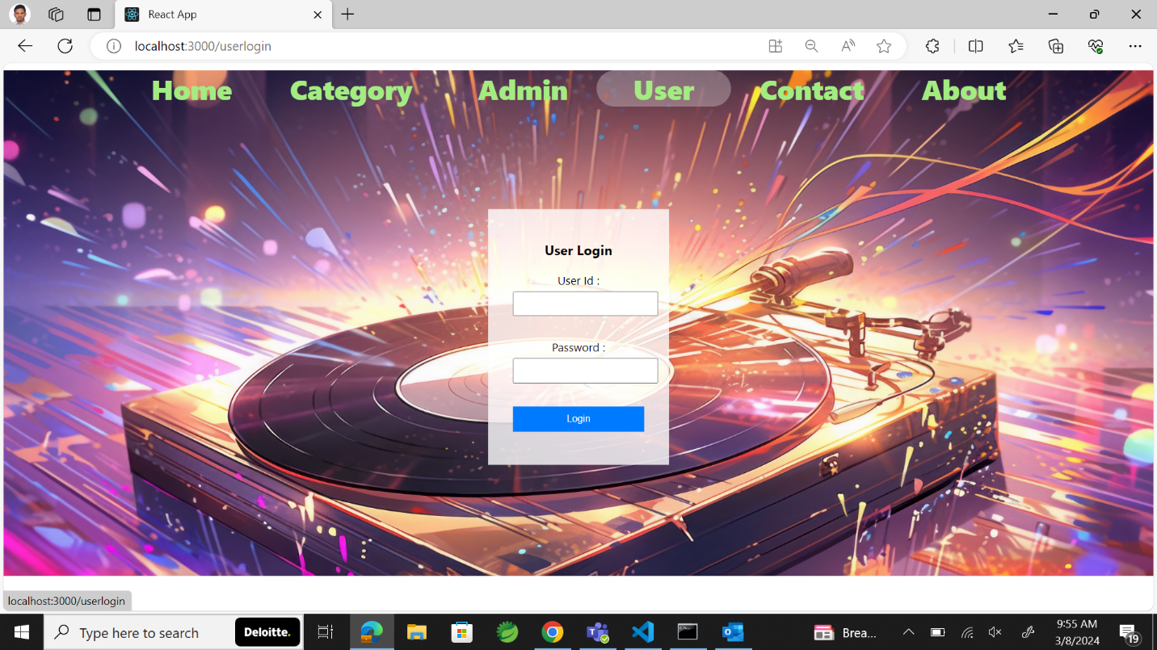

* Here the User Login values are static.
* The User id = saikiran and User password = saikiran123.
* If either the id or password is wrong, it throws an error which is invalid User Id or Password.

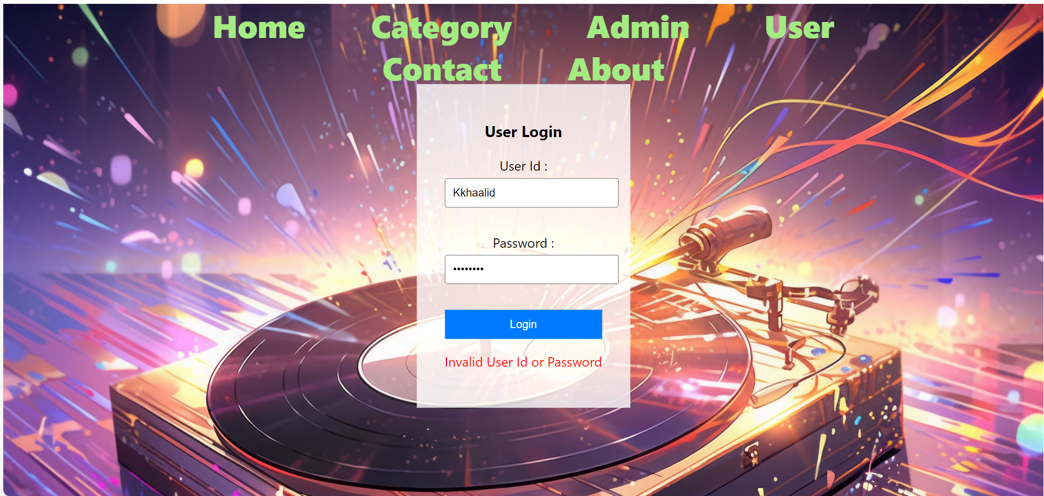

**5) Contact**

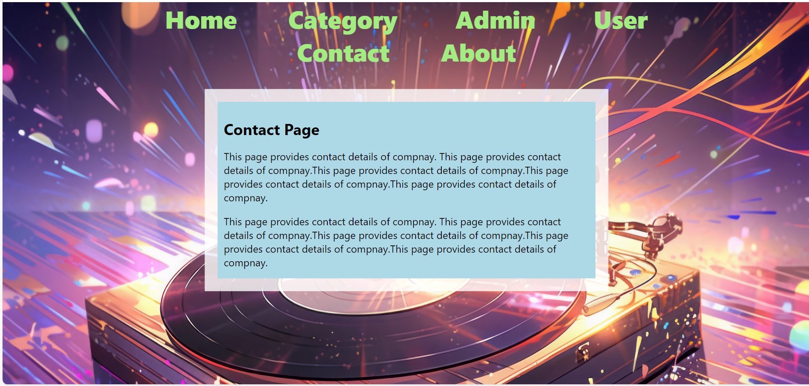

**6)About**

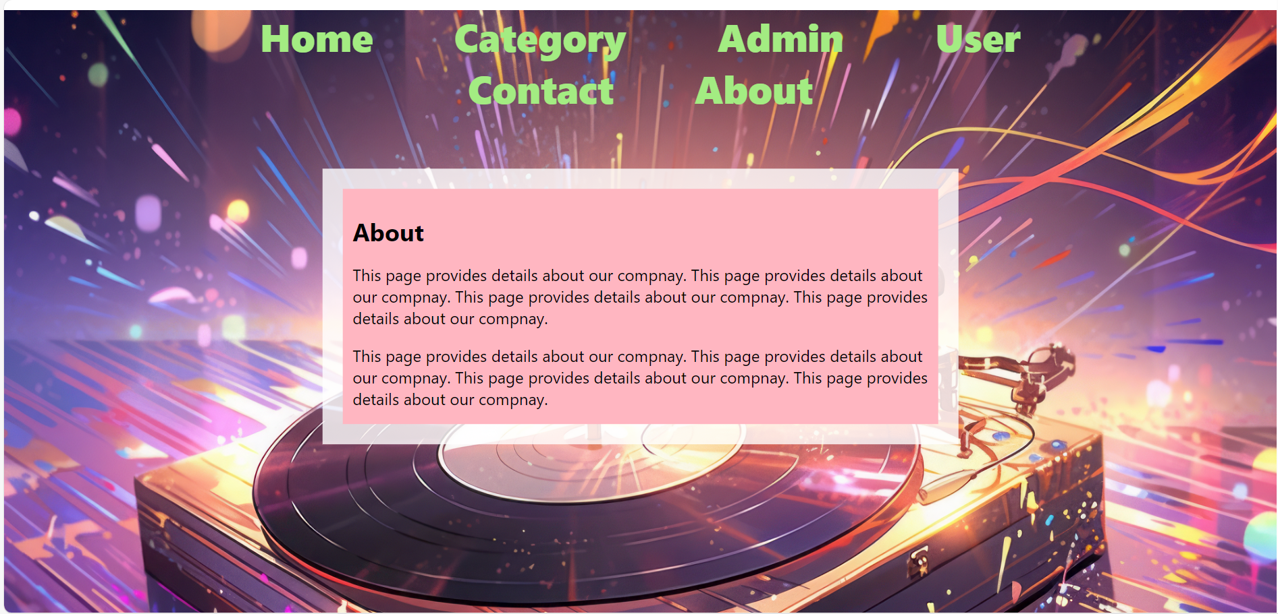

When user login using Admin credentials the user has the authority to perform CRUD (Create, Read, Update, Delete) operations (Using AXIOS).

Axios is a popular JavaScript library used for making HTTP requests from the browser. In the context of React, Axios is often used to fetch data from APIs or send data to a server. It provides a simple and intuitive API that works well with React applications.

Admin Homepage:

* When admin successfully login this is going to be the home screen.

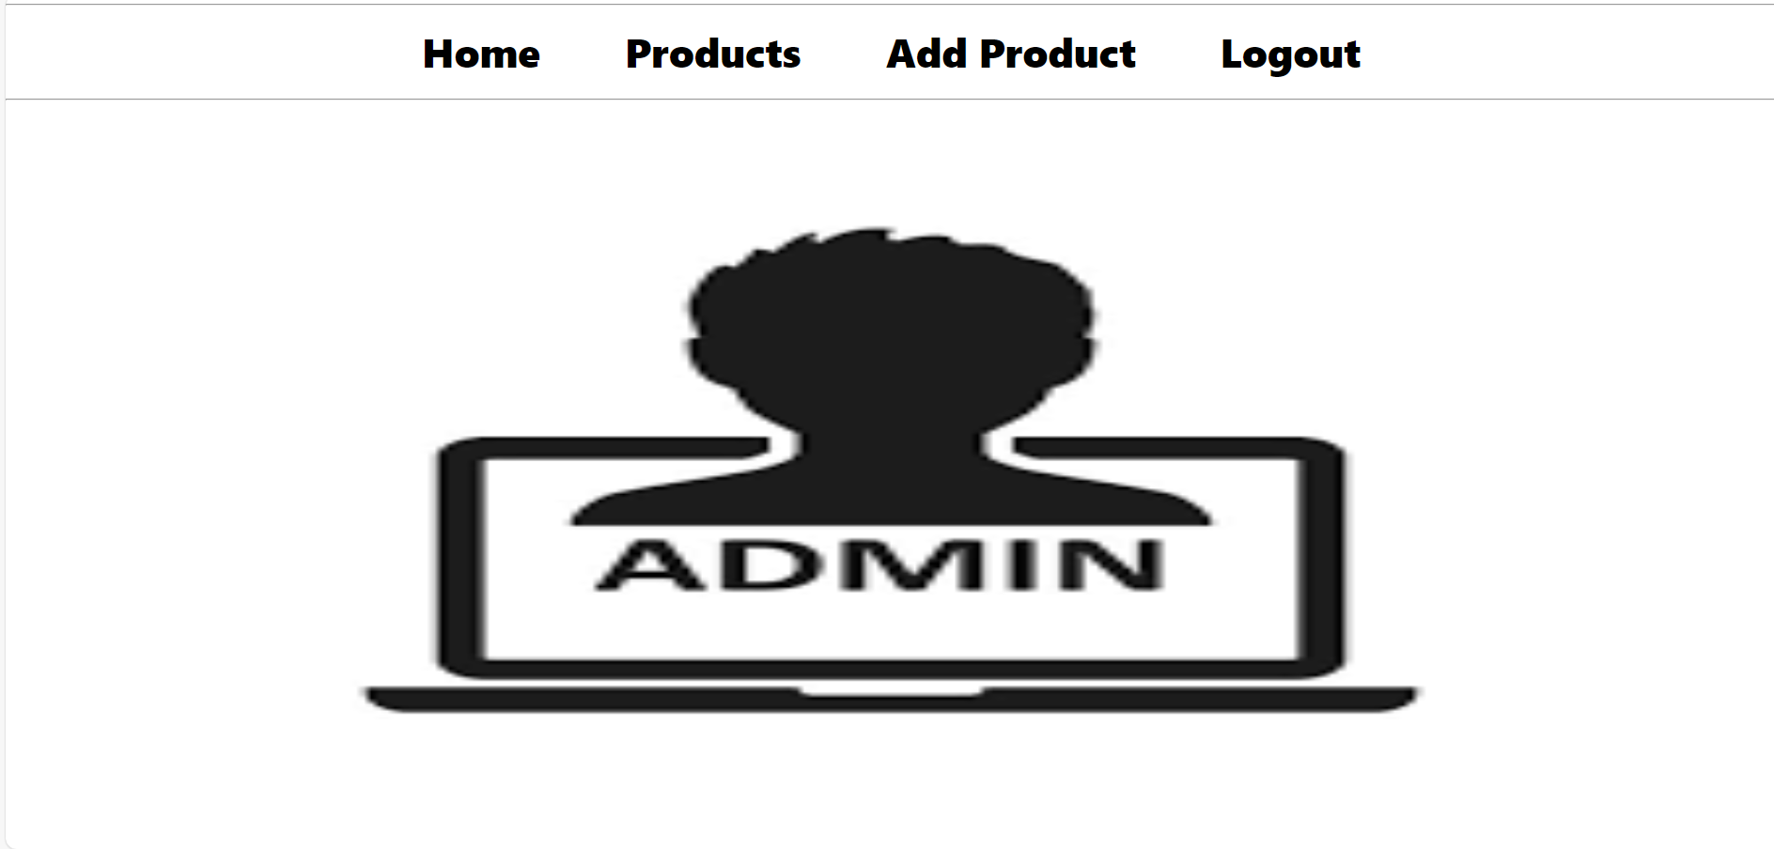

* Here the admin has multiple options Products, Add Product and Logout.
* In the products section he can view all the products he has.
* When admin wants to view the products which he has, he can do it by clicking on the Products button. 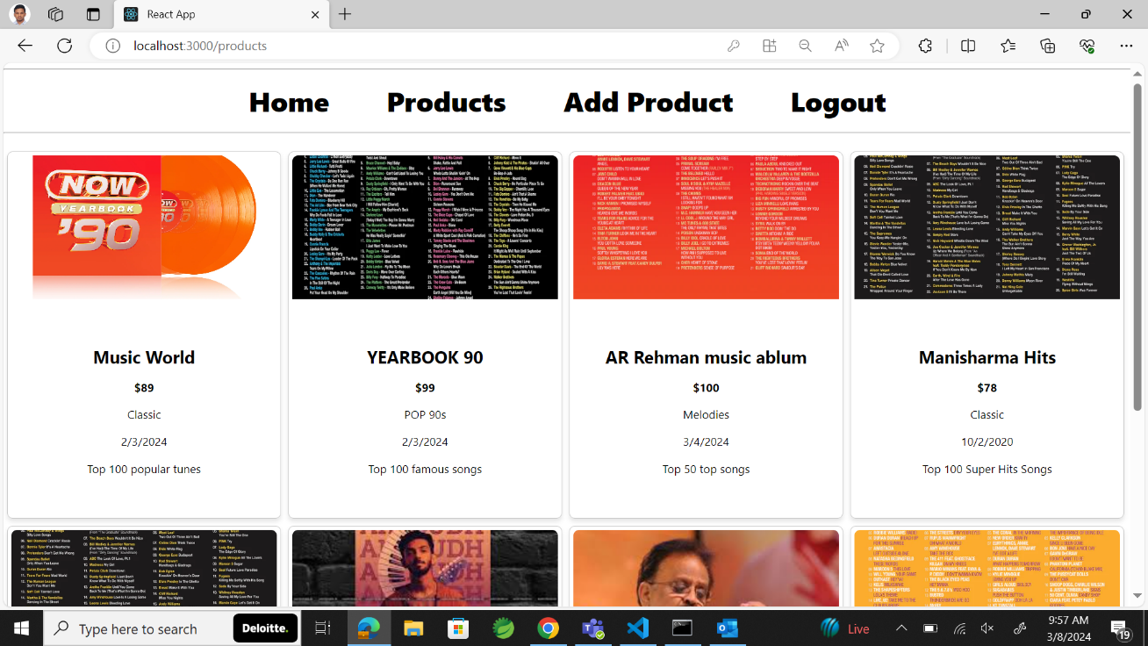
* In the Add Products Section admin can add the product he wants to add by using the given fields ProductId, ProductName, ProductPrice, ReleaseDate, Description, ImageUrl.
* The admin can view the products he has by clicking on the Get Products.
* The admin can Update the products as well if he has any corrections.

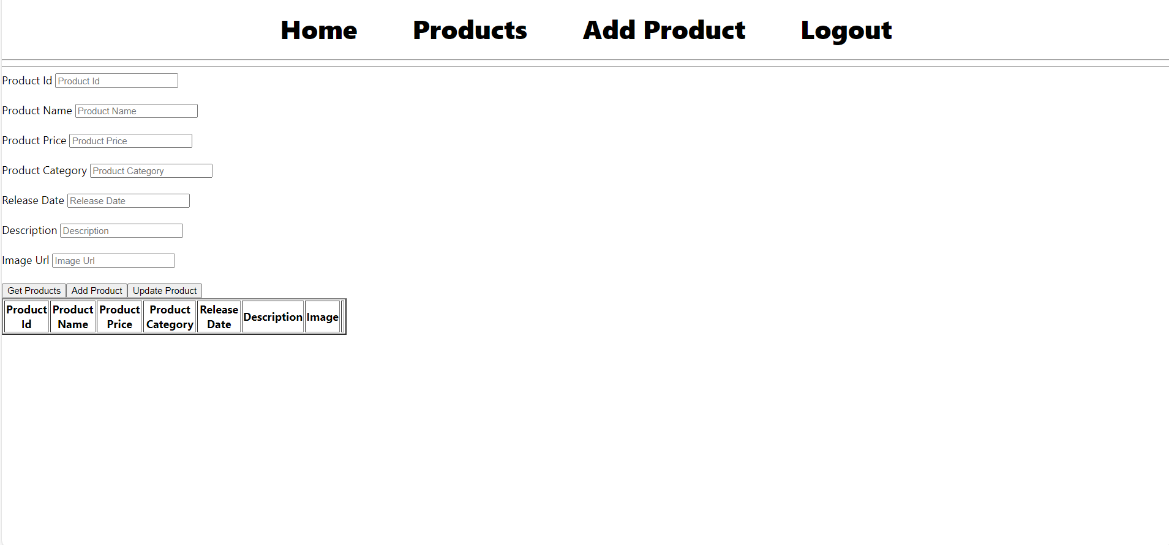

* The Logout is used to come out of the admin portal to the main screen.

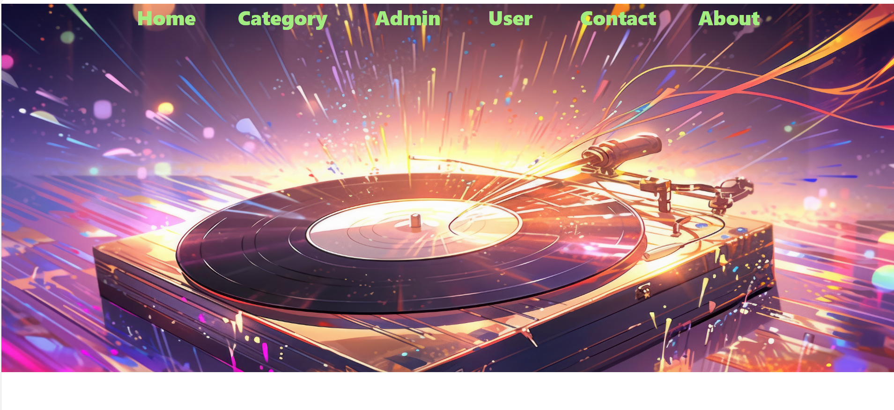

When user login using the Users credentials user’s screen is going to be as..

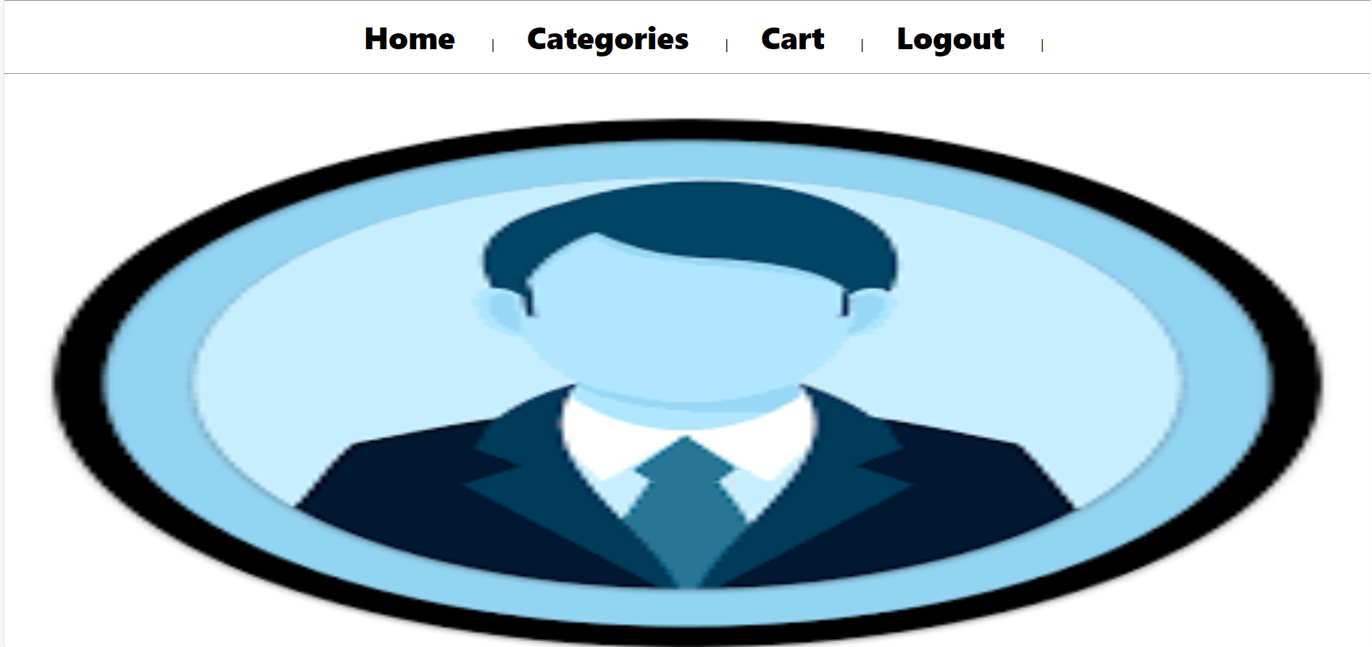

Here the user has four options they are Home, Categories, Cart, Logout.

The above picture is the home screen of the user.

In the categories section the user can view the collection of the music which the music store has.

In this case we have the collection like

* Classic Hits
* Pop 90’s
* Magical Melodies
* Mixed Tunes

And we have an option like ADD TO CART. It is used to add the collection to the users cart the user can even select the Quantity.

Total Items in Cart show the number of items the user has added to his cart.

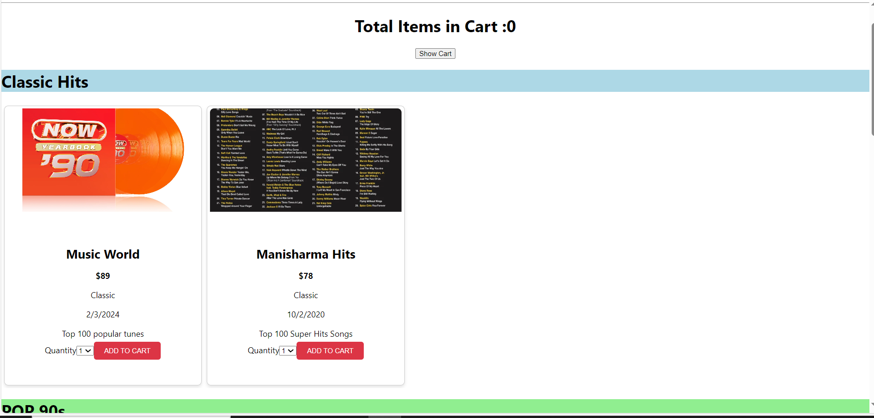

When the user clicks on the show cart option user can view the items which he has added in his cart he has the option to remove as well.

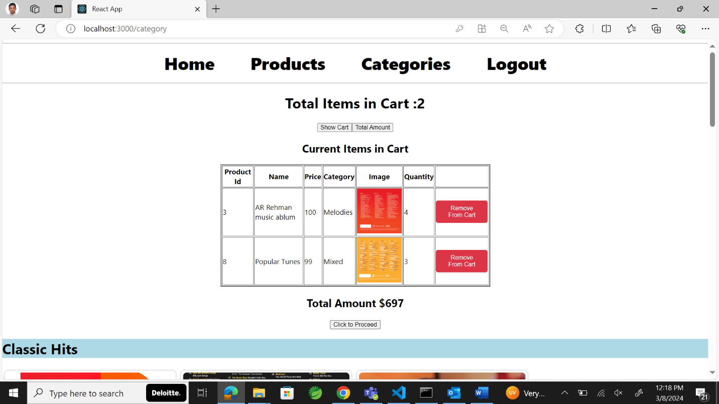

When the user wants to check the Total Amount, he should click on the Total Amount button and user will be navigated to the total amount screen which is this.

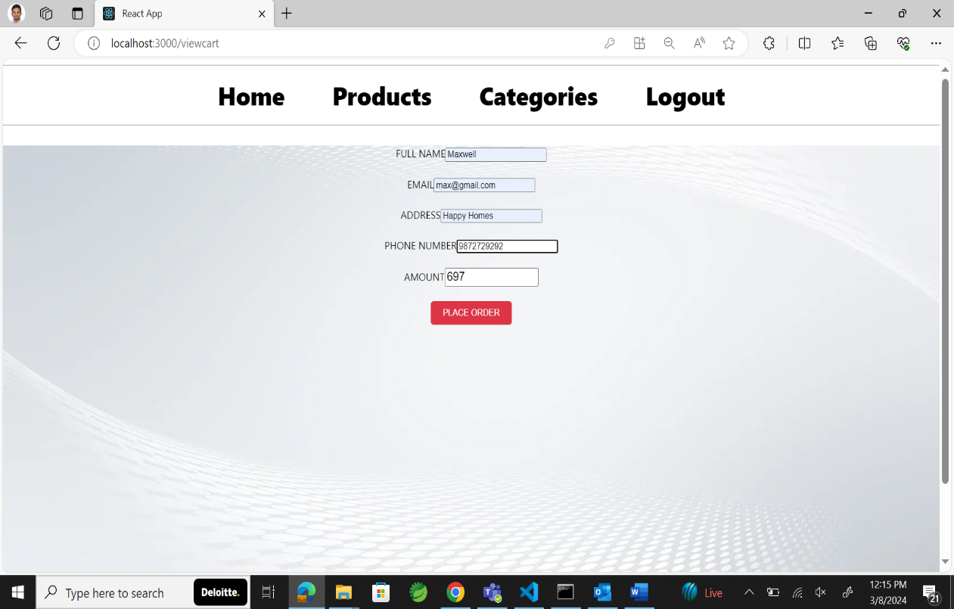

In the total amount category user should fill all the fields and click on the place order his order then user gets an alert saying You have been successfully purchased.

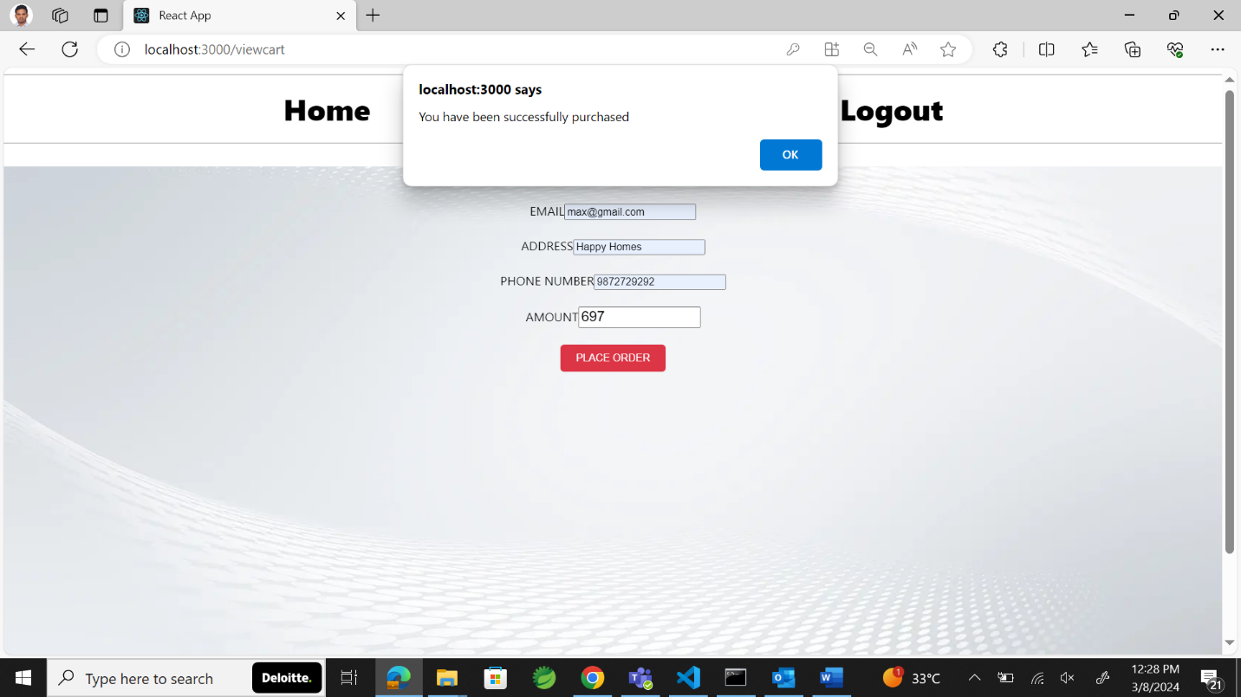

* Logout option lands the user on the Homepage.